|  |  |
| --- | --- |
| **Position Title:** | Store Person - Canterbury |
| **Reports To:** | Warehouse Lead - Canterbury |
| **Direct Reports:** | N/A |
| **Key Relationships:** | * Supply Chain team * Supply Chain Product Specialists – Overhead, Underground & Substations * Regional warehouse teams * Canterbury employees * Internal customers * External Customers |
| **Primary Location:** | Waterloo - Christchurch |
| **Status:** | Full Time – Permanent |
| **Version Date:** | January 2023 |

# **1.0 Our Organisational Profile**

Connetics is a multi-disciplined, multi-regional electrical distribution construction, and maintenance business. We maintain and develop electrical and utilities infrastructure assets for power networks, councils and private entities operating in a highly competitive contracting market. Connetics is a wholly owned subsidiary of Orion NZ Ltd (a Christchurch City Holdings Limited company) which operates within an Orion group ecosystem as the electricity distribution services unit, with an Integrated Leadership Team representing the wider Group context.

Connetics has a current turnover of approximately $100 million, employing approximately 400 people across branches in Wellington, Central Otago, Westport, Paraparaumu as well as our head office and depots in Christchurch.

# **2.0 Our Strategic Context**

Our Orion Group Purpose of **Powering a cleaner and brighter future** captures the contribution we want to make to the wellbeing and prosperity of our communities. Recognising we are in the midst of radical disruption in the energy sector and due to the climate change crisis, we challenged ourselves to consider how we need to adapt, remain relevant and proactively harness opportunities in the fast-evolving energy landscape. We developed our new Group Strategy to respond to the challenges facing our industry and New Zealand, and to position the Orion Group for a new, purpose-led future.

As Orion’s contracting subsidiary, Connetics’ core business is the design, construction and maintenance of overhead and underground power lines and associated equipment. Specialists in electrical distribution, we support Orion with the design and build expertise to maintain and develop their network. We also provide these services to other electricity distribution businesses around New Zealand and are focused on innovating, designing and delivering energy products and services for our customers. Our Purpose ***Delivering energy solutions that enable others to power a cleaner and brighter future for Aotearoa*** encapsulates our role within the Orion Group Strategy.

**Connetics’ strategic focus areas:**

**Growth:** To focus on growth through new customers or new products and services to current customers

**Optimisation:** To deliver smart and efficient processes to make us faster and improve our Operating Model

**Digital:** Deliver the digital services to our stakeholders (customers/employees) that they need to be successful

**Culture:** Deliver an engaged, welcoming, supportive, inclusive high-performance culture

# **3.0 Your Position Purpose**

Reporting to the National Supply Chain Manager, this role will support the delivery of exceptional service to internal and external clients alike through prompt and effective problem solving and consistency of warehouse processes and disciplines. This role will be involved in receiving, warehousing, picking and packing functions to support the timely provision of materials and equipment, while ensuring stock is managed in accordance with the business inventory objectives.

**4.0 Key Accountabilities**

|  |  |
| --- | --- |
| **Warehouse** | * Receives orders from customers and completes the picking and packing functions associated with the supply and transportation of items to site * Completes the issuing and packing of materials * Completes the receipting and/or returning of materials as required * Processes materials transactions within the inventory management system(s) * Maintains the accuracy of the stock by location * Ensures that materials are properly issued and transferred and that scrap materials are recycled in a safe and environmentally conscious manner |
| **Inventory Management** | * Ensures accurate and timely recording / handling of new deliveries * Ensures stock receipts, adjustments and invoices are processed daily so that system stock on hand equals physical stock on hand * Supports a high level of security being maintained over the site, inventory, plant and equipment * Ensures accurate use of inventory control systems and maintenance of data * Conducts physical counts of inventory for stock control and variance assessments * Undertakes regular cycle counts / stock takes including system updating |
| **Customer Service** | * Supports the effective delivery of customer service ensuring mutually beneficial relationships with existing and potential customers |
| **Collaboration** | * Contributes to a culture that achieves a high level of morale within the group and encourages performance, productivity, openness, employee satisfaction and trust. |
| Health & Safety | * Model the expected Health, Safety and Environment behaviours for Connetics. * Ensure compliance with Health and Safety legislation at all times for self and your team. * Proactively identify and eliminate hazards and contribute to the work environment to ensure safety measures are in place, compliant and operational. * Keep yourself safe and follow all processes in the Connetics H&S system, providing feedback on any improvements that can be made. * Support Connetics to provide an emergency response in emergencies and adverse events including weather events. In most situations this will be normal work but may include secondment to different teams and/or different tasks and potentially different locations suited to the individual’s ability and circumstances to enable the provision of comprehensive support to customers and communities. |
| Continuous improvement | * Strong focus on identifying and suggesting ways to improve practices and processes that are hampering the smooth operation of the day to day running of the business |
| **Teamwork and Support** | * Role model expected behaviours and lead by example, proactively championing our values, mission and company/business unit initiatives * Be seen as a positive role model for the Supply and Logistics Team at Connetics, acting with professionalism * Always act for the good of Connetics and in full support of the Connetics goals * Foster and develop effective relationships with team members and all other internal and external customers * Foster and support a learning environment within the immediate team and wider Connetics team by:   + sharing technical knowledge and expertise   + providing training to staff as required   + sharing relevant customer knowledge to enhance customer service |

**5.0 Your Qualification and Experience**

|  |  |  |  |
| --- | --- | --- | --- |
| **Qualifications / Experience** | **Essential** | **Desirable** | **Beneficial** |
| Experience in a warehousing team |  | **✓** |  |
| Experience in electrical supply industry |  |  | **✓** |
| Forklift Licence |  | **✓** |  |
| Intermediate skills with Microsoft Office suite | **✓** |  |  |
| Experience using a database finance system |  | **✓** |  |
| Current and valid driver’s licence |  | **✓** |  |

**Appendix 1 – Orion Group Strategy**

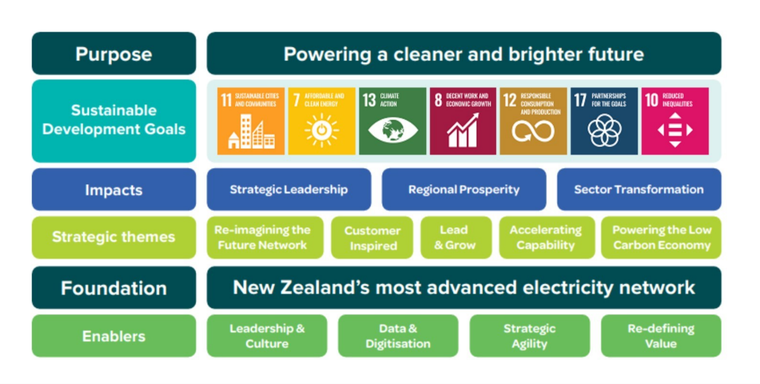

**Appendix 2 – Orion Group Purpose**

