Position Title: | PMO Delivery Manager (Substations)
Reports To: | Head of PMO
Direct Reports: | TBC
Key Relationships: | - Project Management /Administration teams  - Orion Programming team  - Finance / People Capability / Technology & Digital Services / Health, Safety and Environment  - Wider Connetics teams  - Customers  - Network owners  - Local authorities  - Commercial  - General Industry contacts  Delivery Service Partners – i.e. Independent Lines Services, Power Jointing, Lemacon and Ventia
Primary Location: | Christchurch
Status: | Full time
Version Date: | January 2023

1.0 Our Organisational Profile
Connetics is a multi-disciplined, multi-regional electrical distribution construction, and maintenance business. We maintain and develop electrical and utilities infrastructure assets for power networks, councils and private entities operating in a highly competitive contracting market. Connetics is a wholly owned subsidiary of Orion NZ Ltd (a Christchurch City Holdings Limited company) which operates within an Orion group ecosystem as the electricity distribution services unit, with an Integrated Leadership Team representing the wider Group context.

Connetics has a current turnover of approximately $100 million, employing approximately 400 people across branches in Wellington, Central Otago, Westport, Paraparaumu as well as our head office and depots in Christchurch.

2.0 Our Strategic Context
Our Orion Group Purpose of Powering a cleaner and brighter future captures the contribution we want to make to the wellbeing and prosperity of our communities. Recognising we are in the midst of radical disruption in the energy sector and due to the climate change crisis, we challenged ourselves to consider how we need to adapt, remain relevant and proactively harness opportunities in the fast-evolving energy landscape. We developed our new Group Strategy to respond to the challenges facing our industry and New Zealand, and to position the Orion Group for a new, purpose-led future.

As Orion’s contracting subsidiary, Connetics’ core business is the design, construction and maintenance of overhead and underground power lines and associated equipment. Specialists in electrical distribution, we support Orion with the design and build expertise to maintain and develop their network. We also provide these services to other electricity distribution businesses around New Zealand and are focused on innovating, designing and delivering energy products and services for our customers. Our Purpose Delivering energy solutions that enable others to power a cleaner and brighter future for Aotearoa encapsulates our role within the Orion Group Strategy.

Connetics’ strategic focus areas:

Growth: To focus on growth through new customers or new products and services to current customers
Optimisation: To deliver smart and efficient processes to make us faster and improve our Operating Model
Digital: Deliver the digital services to our stakeholders (customers/employees) that they need to be successful
Culture: Deliver an engaged, welcoming, supportive, inclusive high-performance culture

3.0 Your Position Purpose

This position leads, develops and manages the Project Management Team (Substations) to ensure the safe and effective delivery of substation works in a manner that meets internal and external customer’s needs and promotes problem solving, experimenting, broad thinking and growth mindset. Manage the relationship with our Service Delivery Partners and contribute to continuous improvement and learning within the PMO, and across customers and Service Delivery Partners.

4.0 Key Accountabilities

Accountability | Description of Key Tasks
Leadership and Management | Support an ‘Orion Group / PMO First’ performance driven culture within the Project Management (Substations) function. Demonstrate strong, collaborative and inclusive personal leadership behaviours.  Key Tasks:  - Fully embrace the Orion Group strategy and provide leadership by enrolling the team clearly to enable all staff to adhere to the Values.  - Ensure all decisions are implemented in a timely and consistent manner.  - Ensure an environment of continual learning / improvement is maintained at all times.  - Provide leadership and management to develop, build and engage a high performing team through regular mentoring and coaching. Recognise high performance.  - Manage performance of direct reports ensuring objectives and operational requirements are being achieved/exceeded and the team’s resourcing matches the workload.  - Deal with staff issues immediately and ensure the team has high levels of engagement, wellbeing and satisfaction.
Strategic planning and direction | - Ensure staff are fully informed of the Orion Group Strategy.  - Translate the Orion Group Strategy to team work objectives and ensure the team are aware of their obligations in helping to achieve.
Substation Project Management | - Oversee the provision of high-quality end to end project management in conjunction with our Service Delivery Partners.  - Work closely with other PMO functions to ensure seamless works delivery.  - Help lead the development and full utilisation of tools required for the PMO.  - Manage delivery of work when required to maintain currency and knowledge of systems.  - Supporting the team when workloads increase to manage peaks and troughs.  - Management of scheduled and non-scheduled works.
Financial Management and Reporting | - Oversee delivery of the Substations part of the annual programme of work in accordance with the formal agreements between Connetics and its clients including Orion.  - Responsible for ensuring that decisions are made within approved functional budget and financial delegated authority.  - Provide regular reporting to PMO Manager on status of all Substations works along with relevant key indicators.
Business Planning | - Contribute to the development and implementation of the Business Plan.
Health & Safety | - Model the expected Health, Safety and Environment behaviours for Connetics.  - Ensure compliance with Health and Safety legislation at all times for self and your team.  - Proactively identify and eliminate hazards and contribute to the work environment to ensure safety measures are in place, compliant and operational.  - Keep yourself safe and follow all processes in the Connetics H&S system, providing feedback on any improvements that can be made.  - Support Connetics to provide an emergency response in emergencies and adverse events including weather events. In most situations this will be normal work but may include secondment to different teams and/or different tasks and potentially different locations suited to the individual’s ability and circumstances to enable the provision of comprehensive support to customers and communities.
Continuous improvement | - Strong focus on identifying and suggesting ways to improve practices and processes that are hampering the smooth operation of the day to day running of the business.  - Proactively support business improvement initiatives and work collaboratively with teams within the PMO, Delivery partners and Orion to achieve it.
Emergency Response in Adverse Events | - Support the Orion Group to provide an emergency response in emergencies and adverse events including weather events. In most situations this will be normal work but may include secondment to different teams and / or different tasks and potentially different locations suited to the individual’s ability and circumstances to enable the provision of comprehensive support to customers and communities.  - Emergency works – Through an emergency contract arrange work as required (emergency works responsible staff)  - Due to the nature of this business the employee accepts that, on occasion, there may be a requirement to assist in emergency response situations. The employee agrees to work such hours as may be required in an emergency until that emergency period is over. The employee is also expected to flexibly use his / her normal hours if the situation requires it.
Team Work and Support | - Always act for the good of Connetics and in full support of the Orion Group Strategy  - Keep PMO Manager informed of all concerns in a timely manner  - Ensure required documentation is available  - Provide back up to other team members as required.  - Foster and develop effective relationships with team members and all other internal and external customers.  - Foster and support a learning environment within the PMO and wider Connetics team by:  - sharing technical knowledge and expertise;  - providing training to staff as required;  - sharing relevant customer knowledge to enhance customer service  - Carry out specific tasks as directed by the PMO manager
Contracts & Projects | - This role will manage contracts and projects for the PMO as workload dictates. For example Orion Emergency Works, capex and opex work for multiple clients.

5.0 Your Qualification and Experience
Qualifications and Experience
Qualifications / Experience | Essential | Desirable | Beneficial
Project or contract management experience, including pricing / tendering, planning and scheduling works
Experience working in a collaborative environment
Understanding of Contract Management
Team Leadership
Relevant tertiary and / or industry related qualification
Electrical registration and practicing licence (electrical, line mechanic, cable jointer)
Knowledge of the electrical supply industry and affiliated industries that Connetics operates within
Experience in industry and related regulations
Current and valid driver’s licence
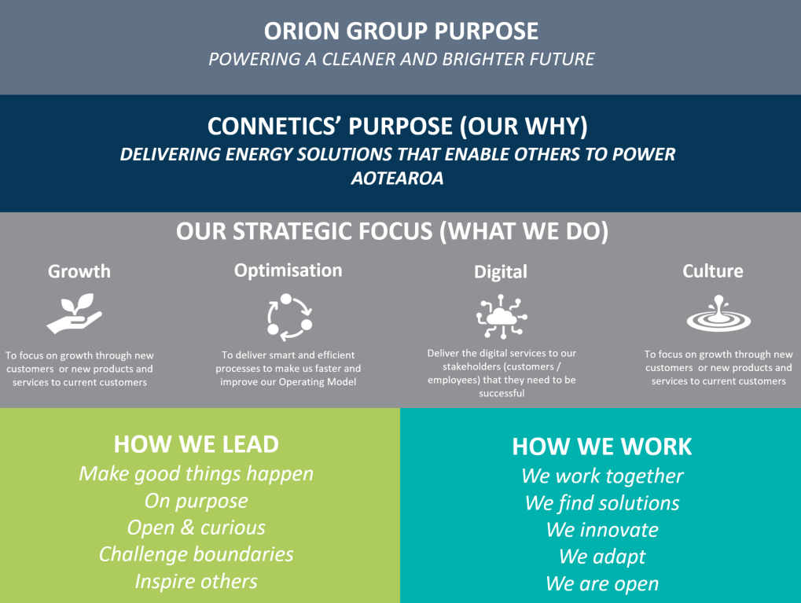
Appendix 2

